Name of Scholarship

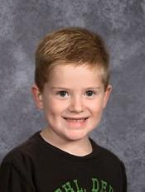

Aiden Collins

